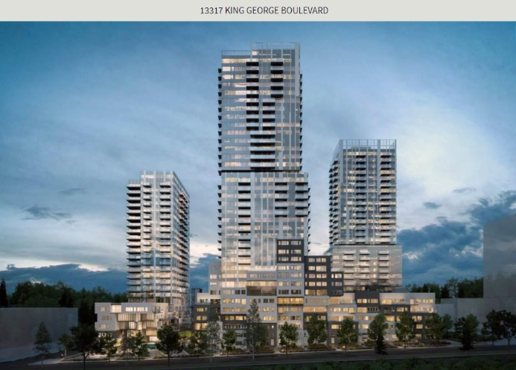

**Address:** 13317 KING GEORGE BOULEVARD, Surrey, British Columbia V3T2T5

**MSL Number:** R2546216

**Value:** $35,855,307

**Description:**

Gateway of the Surrey City Centre. ~500m to skytrain station. An assembly of 3 properties. Total proposed 946,300 gross sq.ft. buildable, 3 High-rises & 2 low-rises. 3rd reading approved.

**Land Size:** 82942 sqft.

**Annual Property Taxes:** $44,926.95

Analysis:

PRO: This building is built in the heart of the city. It is well maintained. There are existing tenants which generated income. The annual cashflow is $800,000 annually on average which represents 13% ROI.

CONS: The building is located in developed area which the potential growth has been priced-in. Therefore, it has lower potential for significant rise in value in the near future.

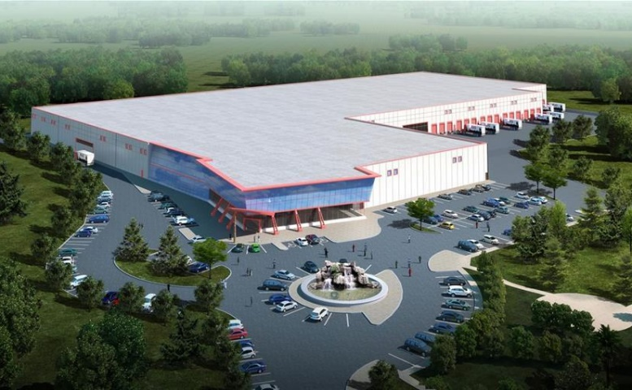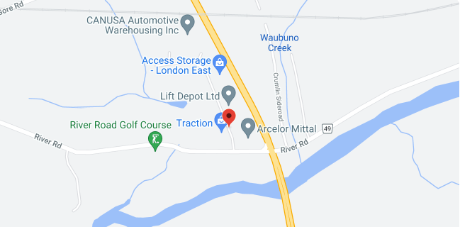

**Address:** 2180 SCANLAN Street Unit# C, London, Ontario N5W6G7

**MSL Number:** 40011184

**Value:** $46,250,000

**Description:**

Exciting new industrial subdivision in east London. This new subdivision has quick access to Hwy 401 via Veterans Memorial Parkway. Build-to-suit opportunities of 50,000 SF up to 1.5 M SF available. Zoned GI1 and L2 allowing for most industrial and warehouse uses.

**Exterior Building Size:** 250,000 sqft.

**Land Size**: 55.57ac

**Annual Property Taxes:** $ 183,449.59

Analysis:

PRO: This building is built in industrial area with quick access to major highway. Since it is a developed warehouse, it has low maintenance cost and low operation cost.

The annual cashflow is $1,200,000 annually on average which represents 23% ROI.

CONS: Far from port of trade and Toronto. High property tax.